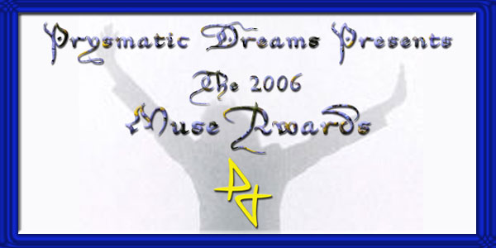

Since 2001
Prysmatic Dreams has made an effort to recognize the contributions of poets and artists
from across the nation and throughout the genre of contemporary Spoken Word & Poetry. As we have grown, so have our opportunities to appreciate the incredible talents so pervasive in our generation.
Join us on January 23rd 10 PM - 12PM EST at a special gathering of
"The Session" Telecypher as we offer our humble gratitude
to these amazing people & places.
Help usstart 2007 by honoring those who made a difference in 2006.

*****

On this star studded night, some of the VIP attendees include:
* The Last Poets
The World famous legends of spoken word
* Will Da Real One
Def Poetry Jam star
* The Poet Essence
7 time Apollo amateur night winner
* Simply Sil
2005-6 S.E.A. Spoken Word artist of the year nominee
* Keith Versatyle Washington
Ebony & Jet feature performer
* Eryk Moore
Author of the new hit CD “This Mans Life”
* Karega Ani
Poet, Emcee & Producer extraordinaire
* Legacy Leonard
Host of VI Radio’s “Rep Your City”
* Janus "J-Ice" Bryant
The Session “Poet of the Year”
* Tremahne Lockhart
Host of the “Oil & Water” Mix show
* Melanie Jordan
Prysmatic Dreams Best New Poet 2006
* Dain Brammage
Prysmatic dreams Performer of the Year 2006
* Maximus Parthas
Prysmatic Dreams Poet Laureate 2006
* NuEshe
Whispered Words Mixtapes Producer of the Year 2006
* Nyne Elementz
Prysmatic Dreams Poet of the Year 2006
* Poetry's Child
Co-Producer for the Whispered words CD of the Year
* Lady Untouchable
Rising Star 2006 Award Winner
* The Poet Black Orchid
Rising Star 2006 Award Winner
* Dawn LifeLived Johnson
Winner of the Whispered Words “Impact Award”
* John Starino
Founder of Columbia SC Phoenix Tongue poetry venue
Including representatives of:
* PoetsInNeed.org
* Oral Essence Magazine
* BzOo Radio
* HipHopPoetry.com
* Whispered Words Poetry Mixtapes
* The Session
* The New Word Order
* Prysmatic Dreams
With All these incredible artists and more
Don't EVEN ask if there will be poetry.
These talented poets and organizations are many of the architects of today’s genre.
Join us as we give thanks for the many unsung efforts of these stars of poetry & Spoken Word
it’s a historic night you CANNOT afford to miss and it's only a phone call away!
ATTENTION ALL NET-radio Stations
Magazines & potential sponsors
* To air this spectacular event live
* cover it in a feature story
* Or have your banner added as a sponsor
Contact us @ PrysmaticDreams@Gmail.com
Or contact Max Parthas
803 749 7493



The Prysmatic Dreams Muse Awards are sponsored by









